ES-brewer detail design

DOC. No.: | REV.: 00 |  |  | PRODUCT:
TITLE: Boiler detail design |  |  |  | Project:
Prepared by: | Hard Lee |  |  | Date:
Remark: | Approval:
Remark: |  | Department | Title |  |  | Signature
Remark: | 1 | Electronic R&D
Remark: | 2
Remark: | 3
Remark: | 4

Revision | Description of Change | Author | Date
00 | Initial version | Hard Lee | 2010.8.13

1. ES-brewer overview 4
2. The mechanical of boiler 4
3. Boiler error code define 4
4. To be continue 4
4.1. Objective 4
4.2. Scope 4
4.3. Reference 4
4.4. Abbreviations 4
4.4.1. heading3 4
Appendix 5

ES-brewer overview
ES-brewer is core component of espresso making, the main functionality include getting the dosage coffee powder, tamping the coffee powder, and form the pressure of the brewing.

The mechanical of espresso brewer.
The old Germany veridical brewer has two main machine parts, sieve head and cylinder. Sieve head is driven by one bi-direction motor and two hall sensor to get the sieve head position. It has three position, open,close,up. and another machine parts is cylinder, it response to hold the coffee powder and tamp the coffee powder. The cylinder has one bi-direction motor to move the cylinder up down.

ES-brewer control state
ES-Brewer control state-charts
The bellowed figure is the es-brewer control state.
  - Dosage pos: get the dosage coffee powder from the grinder.
  - Press coffee power: move the cylinder to press the coffee powder to build a coffee powder.
  - First squeeze: Squeeze the coffee powder with an constant voltage, So water flow resistance is formed.
  - First water: Use a little water to wet the coffee powder.
  - Second water: Continue large water to extract the coffee.
  - Last squeeze: Squeeze the water in coffee cake and release the waster water in drip tray.
  - Wipe waster coffee cake: Sieve head open, cylinder go to the up positon, then sieve head go to the up position, so the waster coffee powder is wiped by sieve head.
  - Return reset position: Cylinder go the down position and sieve head is closed.

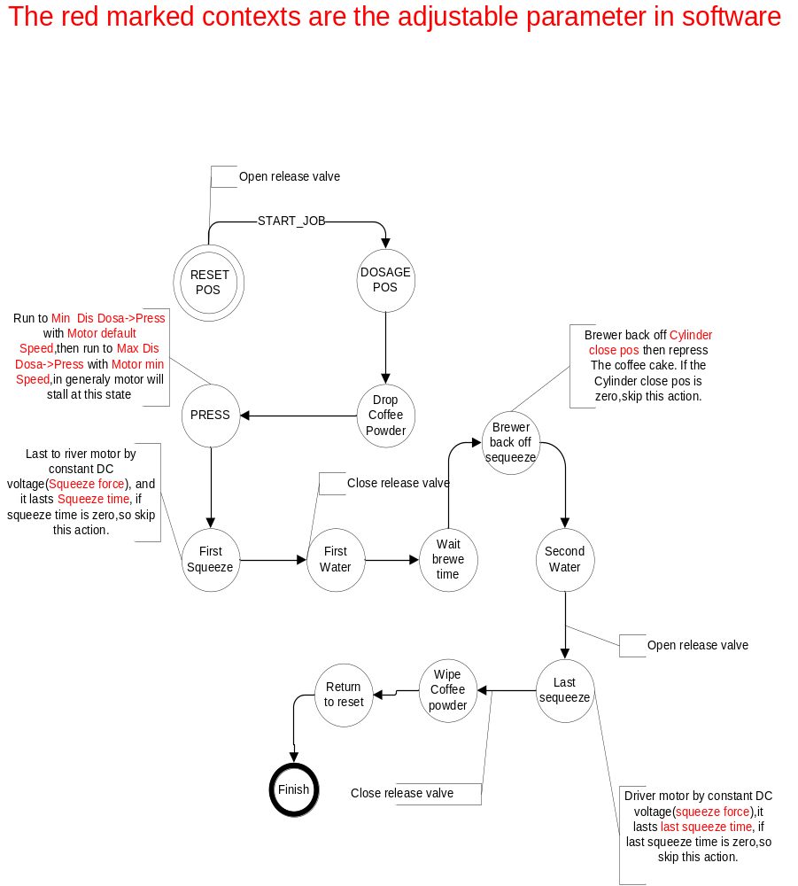

ES brewer error code define

To be continue

Objective

Scope

Reference

Abbreviations

heading3
Normal

Appendix

